APM 2024 FACT SHEET

Event Name | Asia Pacific Maritime (APM)
Event Date | 13 – 15 March 2024
Venue | Marina Bay Sands, Singapore  Halls A, B, C, D, E & F
Current Edition | 18th edition
Website | www.apmaritime.com
Contact Info | +65 6780 4622  apm.marketing@rxglobal.com
Event Description | The Premier Maritime Exhibition for Business Opportunities with Asia  Asia Pacific Maritime (APM) 2024 is the premier exhibition and conference in Asia showcasing a complete overview of the vessel sectors – services and solutions, technology, vessels equipment, machineries, supplies, and many more.  With 17 editions of proven track record, APM gives you 3 days of opportunities to connect with decision makers and sharpen industry understanding in Asia.
Show Size | 21,000sqm
Attendees | Over 15,000 visitors from Asia  More than 1,500 brands from 60 countries
Pavilions | 2018: 18 Official pavilions  (APM’s last physical exhibition since COVID-19)  - Australia - Austria - China P.R.C. - Denmark - Finland - France - Germany - Greece - Holland - Indonesia - Japan - Malaysia - Norway - Singapore - South Korea - Spain - Taiwan Shipbuilding Association - United Kingdom
Media Partners | 99 supporting media from 15 countries
Event Format | 3-day Exhibition to buy, sell and network  3-day high-level Conference with 112 Speakers from 19 countries
Visitor Profile | 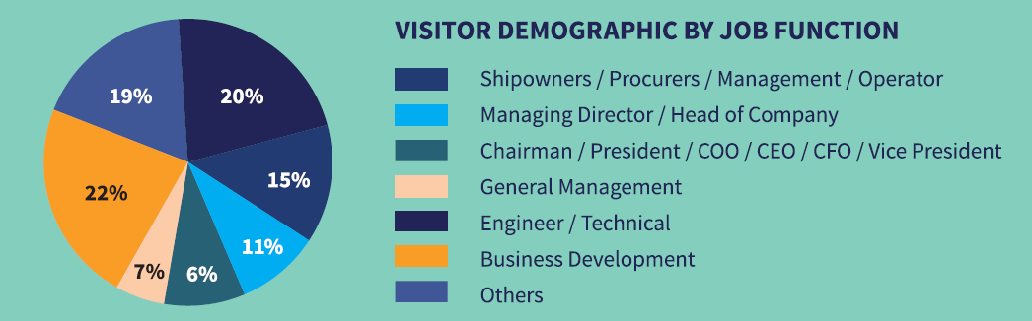
Exhibitor Profile | 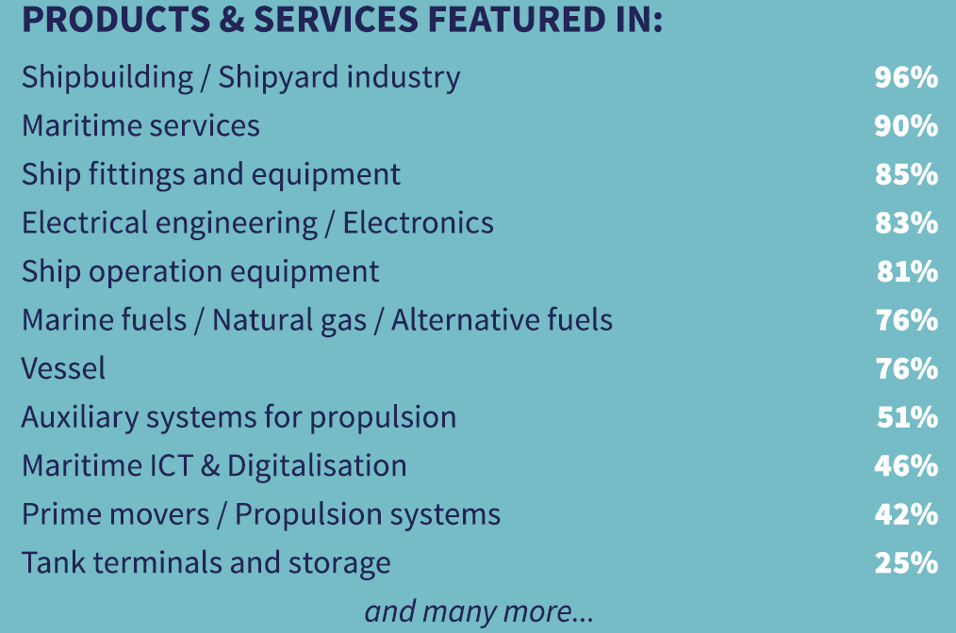
Endorsed by | Approved International Fair (AIF)
Supported by | - Maritime and Port Authority of Singapore (MPA)  - Singapore Exhibition & Convention Bureau
APM Logos | 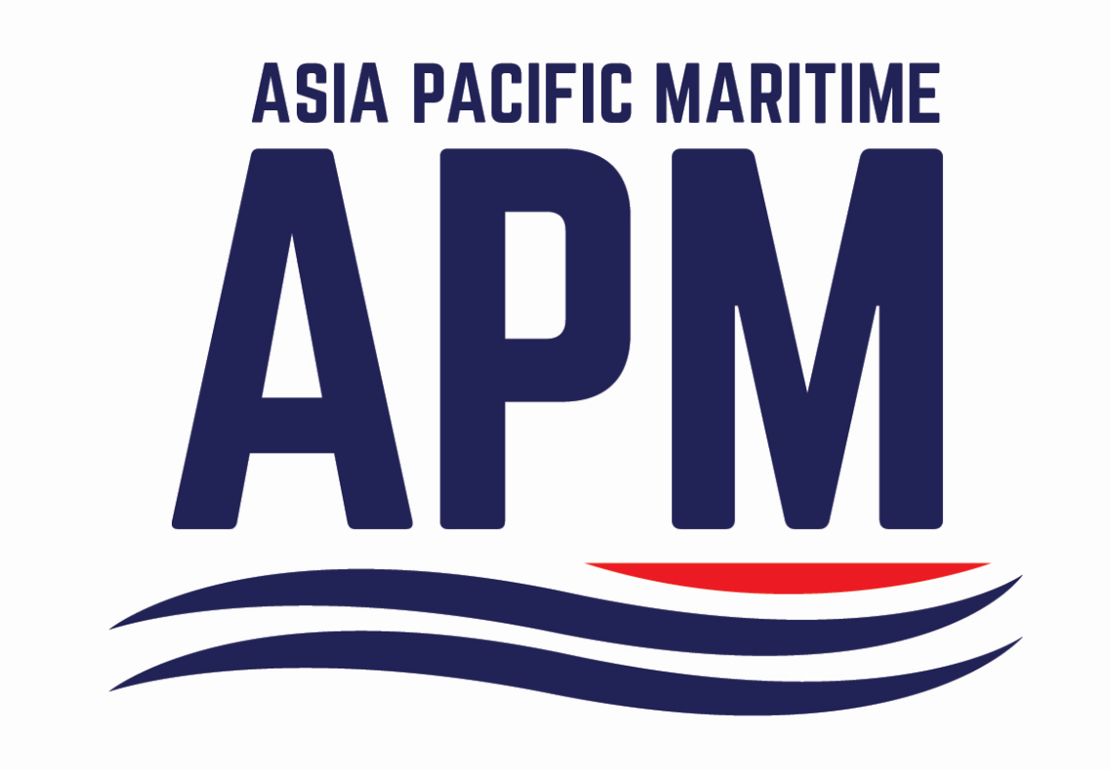
Organised by | About RX Global  RX is in the business of building businesses for individuals, communities and organisations. We elevate the power of face-to-face events by combining data and digital products to help customers learn about markets, source products and complete transactions at over 400 events in 22 countries across 43 industry sectors.  RX is passionate about making a positive impact on society and is fully committed to creating an inclusive work environment for all our people.  RX is part of RELX, a global provider of information-based analytics and decision tools for professional and business customers.www.rxglobal.com

